Web Design and Development

4COSC011W

Report

Author:

Jeeona Andrew

Student ID:

W1810574

Group Number:

C8

Student Role:

Student 2

URL: <https://w1810574.users.ecs.westminster.ac.uk/Title.html>

1. Introduction 3

2. Technical Discussion 4

1. Main page 4

2. External CSS 5

3. Query form 6

4. Page editor page 9

3. Janet 10

Conclusion 11

References 12

Appendices 13

Appendix A: Code 13

Appendix B: Screenshots 31

Appendix C: Individual Statement 35

# Introduction

Our website has been built up related to tourism company. Our team member’s roles are mentioned below.

* Student 1: Umar Mahmoodh - Presentation slide and Shop.
* Student 2: Jeeona Andrew - Main Web page, External CSS and Feedback form.
* Student 3: Dulith De Silva - Quiz and Student details.
* Student 4: Sheron Fernando - Gallery and Sitemap.

We chose tourism to design our website. Technical discussion, UI and UX principles used, color balance, consistency, Accessibility, Janet rules, the code of this website and individual details works are described below.

# Technical Discussion

Technical discussions describe the unique or main features of our website. This is all our team members got together to build a solution for making our website. This is where our main role has been clearly stated.

Therefore, as a second student, my task is to create a homepage, external CSS for logo, navigation bar and query form. Each of my work will be explained below.

## Main page

The homepage is the homepage and will be displayed to web visitors after the student 1

4-seconds slide.



The above page is the home page or main page. It will be displayed on Slideshow. At the top of the page is the navigation bar, which leads us to Click on other pages of the site. To make the navigation bar look beautiful and fresh Some hover effects have been added. These are described under the external CSS theme. There is also a small background image slideshow and some details about the webpage.

## External CSS

External CSS is common to all web pages. It contains the code of the logo, alignment, navigation bar and CSS style. Code and screenshots the navigation bar is described below.

Logo and navigation bar:

Logo:

.logo{

    width: 80px;

    height: 80px;

    margin-left: 30px;

}

Output:



Navigation bar:

.topnav{

    overflow: hidden;

    background:white;

    padding: 15px 10px;

}

.topnav a {

    color: black;

    padding: 14px 16px;

    text-decoration: none;

    font-size: 17px;

    text-transform: uppercase;

    float: left;

    text-align: center;

}

.topnav a:hover {

    background-color: #2697cd;

    color: black;

}

.topnav a.active {

    background-color: #2697cd;

    color: black;

}

.header{

    float: right;

}

## Query form

This is where page visitors can rate and comment our website. To create this form, I used the form tag in html, and used the label, text area, and single selection buttons. To design the form, I used some CSS styles. At last the output is as follows.

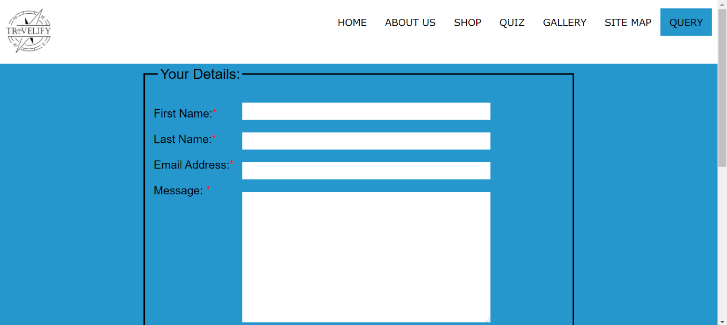



JavaScript have been used to make this code follow claim. The warning box after filling out the form was created using the following function JavaScript. A screenshot of the code and its respective output are as mentioned below.

 <script>

  function validation(){

    var fname = document.getElementById("fname").value;

    var lname = document.getElementById("lname").value;

    var email = document.getElementById("email").value;

    var comment_text = document.getElementById("comment_text").value;

    if(fname.length <= 3 ){

        alert("please enter valid first name ")

        return false;

    }

      else if(lname.length <= 3 ){

        alert("please enter valid last name ")

        return false;

    }

      else if(email.indexOf("@") == -1 || email.indexOf(".") == -1 || email.length < 8){

        alert("please enter valid e-mail ")

        return false;

    }

      else if(comment_text.length < 1){

        alert("Enter a valid message")

        return false;

    }

    alert("Hi  " + fname +" "+ lname +" your form has submited successfully we will revert you.")

    return true;

  }

  </script>

**If the user did not type first name the alert will be shown as below**

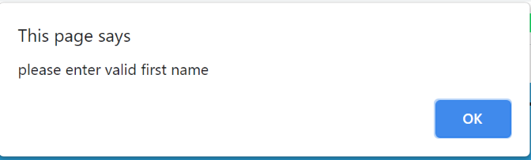

**If the user did not type last name the alert will be shown as below**

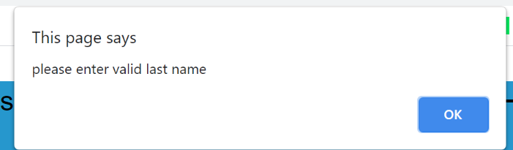

**If the user did not type email the alert will be shown as below**

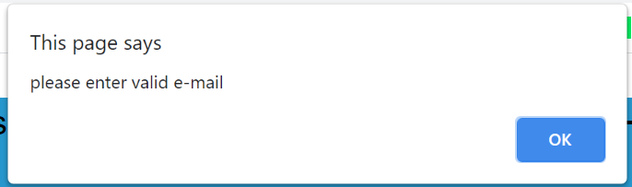

**If the user did not type message the alert will be shown as below**

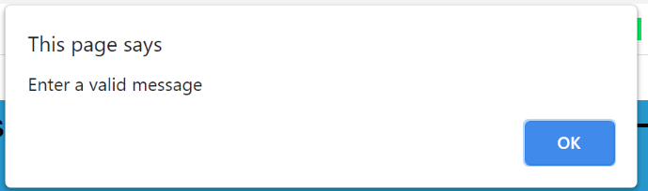

**If the user typed all the information and submit it the alert will be shown as below**

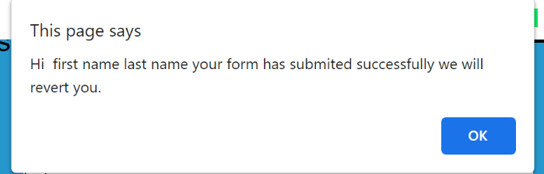

## Page editor page

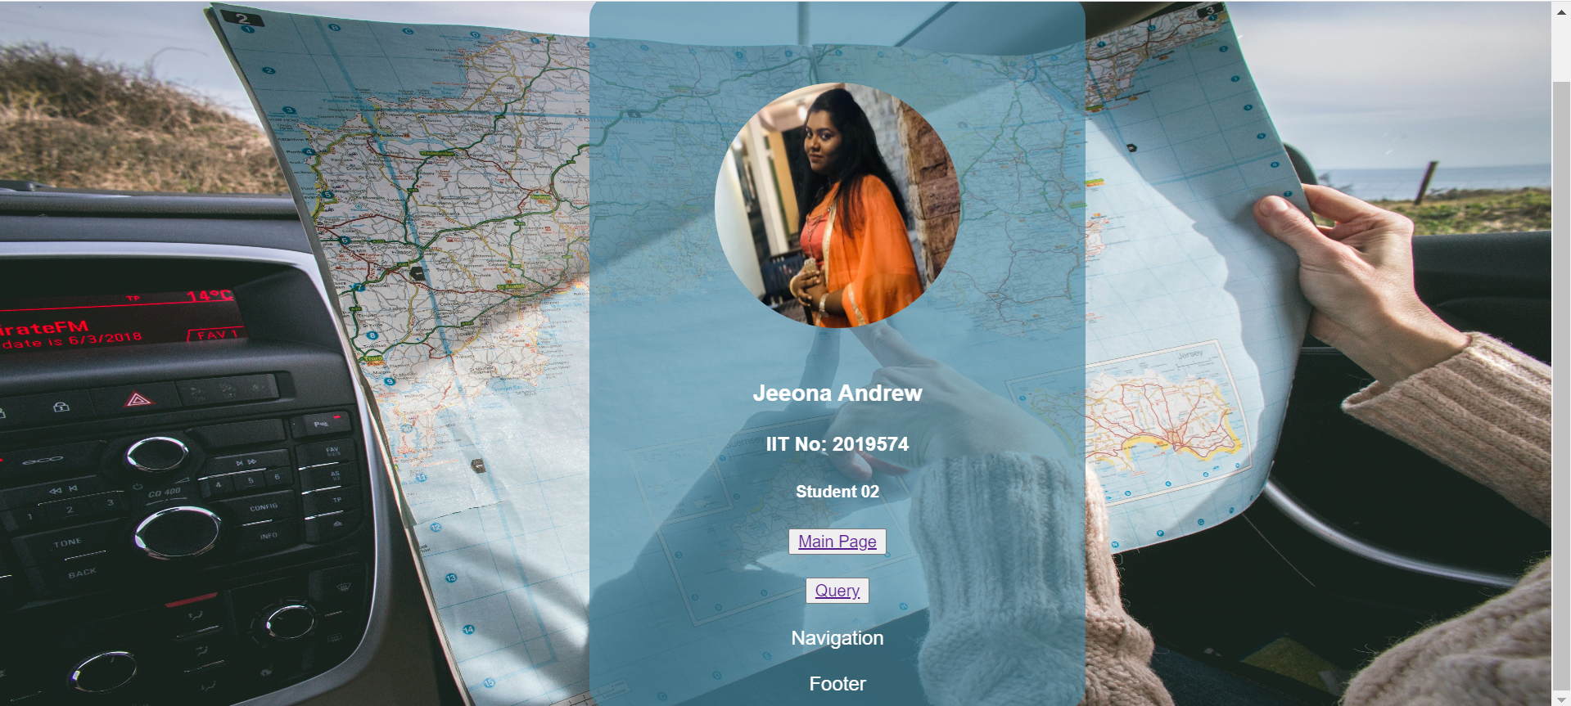

# Janet

Janet is a global network. This provides the following functions search for copyright policies from other sources and prevent copyright protection of their copyrights content. Some sub-components are mentioned below.

* Enable customers to use the system safely through preparations, methods and frameworks
* Manage and be responsible for a single client’s visit to Janet
* Manage the hazards of unstable system accessories and take recommended safety measures
* Investigate, contain and resolve security breaches.

To maintain these principles, our member group uses a common theme declaration and style and verification system. This is how we follow the Janet Principles on the website.

# 

# Conclusion

The report contains all the details of my webpage and the details of the role I was assigned to on the group website. The development of web pages gave me a good understanding of HTML, CSS and JavaScript. The report details the navigation bar, external CSS and feedback form. The bonding of team members, company and team spirit, and leadership abilities prompted us to set the goal, which is to create a tourism-related website based on the themes and colours we plan to have. Learn a new way to use online tools to check the readability of web pages. The colour contrast of web pages provides me with more opportunities to correct errors. As the final output, we have completed the required work.

# 

# References

W3schools.com. 2021. *CSS Navigation Bar*. [online] Available at: <https://www.w3schools.com/css/css_navbar.asp> [Accessed 5 March 2021].

W3schools.com. 2021. *HTML footer Tag*. [online] Available at: <https://www.w3schools.com/tags/tag_footer.asp> [Accessed 6 March 2021].

W3schools.com. 2021. *HTML Forms*. [online] Available at: <https://www.w3schools.com/html/html_forms.asp> [Accessed 7 March 2021].

W3schools.com. 2021. *JavaScript Popup Boxes*. [online] Available at: <https://www.w3schools.com/js/js_popup.asp> [Accessed 9 March 2021].

W3schools.com. 2021. *W3.CSS Slideshow*. [online] Available at: <https://www.w3schools.com/w3css/w3css_slideshow.asp> [Accessed 11 March 2021].

# 

# Appendices

## Appendix A: Code

main.html

<!DOCTYPE html>

<html lang="en">

<head>

<meta charset="UTF-8">

<meta http-equiv="X-UA-Compatible" content="IE=edge">

<meta name="viewport" content="width=device-width, initial-scale=1.0">

<title>main</title>

<link rel="stylesheet" href="style.css">

</head>

<body>

<header>

<div class="topnav">

<img src="images/travelify.png"class="logo" >

<div class="header">

<a class="active"href="">Home</a>

<a href="">About us</a>

<a href="">Shop</a>

<a href="">Quiz</a>

<a href="">Gallery</a>

<a href="">Site Map</a>

<a href="Query.html">Query</a>

</div>

</div>

</header>

<div id="slideshows" data-component="slideshow">

<div role="list">

<div class="slide">

<img src="images/image1.jpeg" alt="image1" class="pics">

</div>

<div class="slide">

<img src="images/image2.jpeg" alt="image2" class="pics">

</div>

<div class="slide">

<img src="images/image3.jpeg" alt="image3" class="pics">

</div>

<div class="slide">

<img src="images/image4.jpeg" alt="image4" class="pics">

</div>

</div>

</div>

<div >

<h1 >

Welcome to Travelify

</h1>

<p>Travelify is not just a tourism company it brings your dream destination trips to live.

You choose the place to travel and keep a budget we will arrange your services accordingly.<br>

Are you spending your yearly savings on Vacation?<br>

we are there to help you. affordable trips are no more a dream.

</p>

</div>

<div>

<img src="images/image5.jpeg" class="img1">

<img src="images/image6.jpeg" class="img2">

<img src="images/image7.jpeg" class="img3">

</div>

<div>

<p>

<u><b> Book & Travel With Confidence </u></b><br>

Commitment to Flexible Terms: The pandemic’s impact on travel is evolving rapidly. To help you plan and book your trips with confidence, Travelify is continually working with our travel partners to offer more flexible booking and postponement terms to protect your travel investment. These terms will be communicated clearly prior to your booking.<br><br>

Commitment to Health & Safety: In the era of Covid-19, travel must be adapted with health and safety considerations at every step. Travelify and our travel specialist partners commit to considerations such as: <br> <br>

Planning for your well-being: The inclusion of factors such as more open space, avoiding crowds, physical distancing, availability of hand sanitizers and masks, etc.

Exceptional health and safety standards: The selection of appropriate hotels, restaurants, guides, etc. that meet our high health and safety standards.

24/7 support and real-time adjustments: The ability to adjust schedules and routes to adapt to unforeseen circumstances.

</p>

</div>

<h1 >Featured Products</h1>

<div >

<img src="images/tent1.png" class="products">

<img src="images/jacket2.png"class="products" >

<img src="images/glove2.png" class="products">

<img src="images/bag3.png" class="products">

</div>

<div id="shop-now-div">

<a href="shopy.html">

<button id="shop-now-btn">Shop now</button>

</a>

</div>

<button><a href="jeeona.html">Editor Page</a></button>

<script >

var slideshows = document.querySelectorAll('[data-component="slideshow"]');

// Apply to all slideshows that you define with the markup wrote

slideshows.forEach(initSlideShow);

function initSlideShow(slideshow) {

var slides = document.querySelectorAll(`#${slideshow.id} [role="list"] .slide`); // Get an array of slides

var index = 0, time = 5000;

slides[index].classList.add('active');

setInterval( () => {

slides[index].classList.remove('active');

//Go over each slide incrementing the index

index++;

// If you go over all slides, restart the index to show the first slide and start again

if (index === slides.length) index = 0;

slides[index].classList.add('active');

}, time);

}

</script>

<footer>

<div class='contact'>

<h3>MORE INFORMATION</h3>

<img src="images/phone.png" alt="phone" style="height:10%;"> &#160 0112345500<br><br>

<img src="images/email.png" alt="email" style="height: 9%;"> &#160 <a href="mailto:travelify@gmail.com"> travelify@gmail.com </a><br><br>

<img src="images/location.png" alt="location" style="height:10%;"> &#160 132A-12/6 st.james road, colombo-13 SriLanka<br><br><br>

<div id='footer_icons'>

<img src="images/facebook.png" alt="facebook" style="height:48%; padding-right:5%;">

<img src="images/twitter.png" alt="twitter" style="height:47%; padding-right:5%;">

<img src="images/instagram.png" alt="instagram" style="height:45%; padding-right:7%;">

<img src="images/pinterest.png" alt="pinterest" style="height:38%; padding-bottom:1%; padding-right:6%;">

<img src="images/youtube.png" alt="youtube" style="height:45%; ">

</div>

</div>

<div class='subform'>

<form><!--this form is non-functional-->

<h3>NEWSLETTER</h3>

Subscribe to our newsletter.<br>

<input type='text' id='name' placeholder='Name'><br><br>

<input type='text' id='email' placeholder='Email'><br><br><br>

<button class="formlink">Subscribe</button>

</form>

</div>

</footer>

</body>

</html>

**style.css**

*{

margin: 0%;

padding:0%;

text-decoration: none;

list-style: none;

box-sizing: border-box;

}

body{

font-family: Verdana, sans-serif;

background-color: #2697cd;

}

.logo{

width: 80px;

height: 80px;

margin-left: 30px;

}

.topnav{

overflow: hidden;

background:white;

padding: 15px 10px;

}

.topnav a {

color: black;

padding: 14px 16px;

text-decoration: none;

font-size: 17px;

text-transform: uppercase;

float: left;

text-align: center;

}

.topnav a:hover {

background-color: #2697cd;

color: black;

}

.topnav a.active {

background-color: #2697cd;

color: black;

}

.header{

float: right;

}

[data-component="slideshow"] .slide {

display: none;

}

[data-component="slideshow"] .slide.active {

display: block;

}

.pics{

height:450px;

width: 100%;

}

h1{

font-family: 'Chango', cursive;

color: white;

font-size: 50px;

margin-left: auto;

margin-right: auto;

width: 11em;

}

p{

font-family: 'Chango', cursive;

color: white;

font-size: 20px;

margin-left: auto;

margin-right: auto;

width: 25em;

}

.img1{

width: 30%;

height: 500px;

}

.img2{

width: 35%;

height: 500px;

}

.img3{

width: 34%;

height: 500px;

}

.products{

width: 23%;

height: 250px;

}

#shop-now-btn{

text-align: center;

margin: 0 45%;

width: 10%;

height: 65px;

border-radius: 15px;

outline: none;

border:none;

cursor:pointer;

}

footer{

background: url("images/footer_image.jpeg");

background-position: center;

background-size: cover;

height:400px;

width:100%;

color:white;

}

footer a{

color:rgb(0, 0, 0);

text-decoration:none;

border:2px solid rgb(0, 0, 0);

padding:5px;

font-size:20px;

font-family: 'Blinker', sans-serif;

font-family: 'Cinzel', serif;

font-family: 'Staatliches', cursive;

}

footer a:hover{

background-color:rgb(0, 0, 0);

color:rgb(255, 255, 255);

transition:0.4s;

}

footer i, footer h3{

color:rgb(0, 0, 0);

}

footer h3{

font-family: 'Blinker', sans-serif;

font-family: 'Cinzel', serif;

font-family: 'Staatliches', cursive;

font-size:25px;

}

.contact{

width:20%;

float:left;

margin-left:10%;

margin-top:3%;

height:290px;

color: rgb(43, 0, 0);

font-weight: bold;

}

.subform{

width:20%;

float:right;

margin-left:10%;

margin-top:3%;

height:290px;

color: rgb(43, 0, 0);

font-weight: bold;

}

#footer_icons {height:28%;}

#footer_icons img:hover{filter: invert(94%) sepia(0%) saturate(368%) hue-rotate(132deg) brightness(99%) contrast(114%); cursor:pointer;}

**Query.html**

<!DOCTYPE html>

<html lang="en">

<head>

<meta charset="UTF-8">

<meta http-equiv="X-UA-Compatible" content="IE=edge">

<meta name="viewport" content="width=device-width, initial-scale=1.0">

<title>Query</title>

<link rel="stylesheet" href="Query.css">

</head>

<body>

<header>

<div class="topnav">

<img src="images/travelify.png"class="logo" >

<div class="header">

<a href="main.html">Home</a>

<a href="">About us</a>

<a href="">Shop</a>

<a href="">Quiz</a>

<a href="">Gallery</a>

<a href="">Site Map</a>

<a class="active" href="">Query</a>

</div>

</div>

</header>

<div class="form" >

<form onsubmit="return validation()" name="comments" id='comments'>

<fieldset>

<legend>Your Details:</legend>

<div id='fields'>

First Name:<span style="color:red;">*</span><br><br>

Last Name:<span style="color:red;">*</span><br><br>

Email Address:<span style="color:red;">*</span><br><br>

Message: <span style="color:red;">*</span> <br><br>

</div>

<div id='input'>

<input type='text' id='fname' name='fname' ><br><br>

<input type='text' id='lname' name='lname' ><br><br>

<input type='text' id='email' name='email' ><br><br>

<textarea id="comment_text" rows="15" cols="100" ></textarea><br><br>

<div id='input_check1' style='color:red;'></div><!--display error message-->

</div>

<button type="submit" id="submit_btn">Submit</button>

<button type="reset">Reset</button>

</fieldset>

</form>

</div>

<script>

function validation(){

var fname = document.getElementById("fname").value;

var lname = document.getElementById("lname").value;

var email = document.getElementById("email").value;

var comment_text = document.getElementById("comment_text").value;

if(fname.length <= 3 ){

alert("please enter valid first name ")

return false;

}

else if(lname.length <= 3 ){

alert("please enter valid last name ")

return false;

}

else if(email.indexOf("@") == -1 || email.indexOf(".") == -1 || email.length < 8){

alert("please enter valid e-mail ")

return false;

}

else if(comment_text.length < 1){

alert("Enter a valid message")

return false;

}

alert("Hi " + fname +" "+ lname +" your form has submited successfully we will revert you.")

return true;

}

</script>

<footer>

<div class='contact'>

<h3>MORE INFORMATION</h3>

<img src="images/phone.png" alt="phone" style="height:10%;"> &#160 0112345500<br><br>

<img src="images/email.png" alt="email" style="height: 9%;"> &#160 <a href="mailto:travelify@gmail.com"> travelify@gmail.com </a><br><br>

<img src="images/location.png" alt="location" style="height:10%;"> &#160 132A-12/6 st.james road, colombo-13 SriLanka<br><br><br>

<div id='footer_icons'>

<img src="images/facebook.png" alt="facebook" style="height:48%; padding-right:5%;">

<img src="images/twitter.png" alt="twitter" style="height:47%; padding-right:5%;">

<img src="images/instagram.png" alt="instagram" style="height:45%; padding-right:7%;">

<img src="images/pinterest.png" alt="pinterest" style="height:38%; padding-bottom:1%; padding-right:6%;">

<img src="images/youtube.png" alt="youtube" style="height:45%; ">

</div>

</div>

<div class='subform'>

<form><!--this form is non-functional-->

<h3>NEWSLETTER</h3>

<p>Subscribe to our newsletter.</p><br>

<input type='text' id='name' placeholder='Name'><br><br>

<input type='text' id='email' placeholder='Email'><br><br><br>

<button class="formlink">Subscribe</button>

</form>

</div>

</footer>

</body>

</html>

**Query.css**

*{

margin: 0%;

padding:0%;

text-decoration: none;

list-style: none;

box-sizing: border-box;

}

body{

font-family: Verdana, sans-serif;

background-color: #2697cd;

}

.logo{

width: 80px;

height: 80px;

}

.topnav{

overflow: hidden;

background:white;

padding: 15px 10px;

}

.topnav a {

color: black;

padding: 14px 16px;

text-decoration: none;

font-size: 17px;

text-transform: uppercase;

float: left;

text-align: center;

}

.topnav a:hover {

background-color: #2697cd;

color: black;

}

.topnav a.active {

background-color: #2697cd;

color: black;

}

.header{

float: right;

}

.form {

top: 0px;

position:relative;

}

.form fieldset{

margin:0% 20% 5% 20%;

font-size:20px; /* font size of form content*/

border:3px solid black;

font-family: 'Oswald', sans-serif;

background-color: #2697cd;

padding-top:2%;

}

.form legend{

color: black;

background-color: #2697cd;

padding: 0.5%;

font-size: 25px;/*font size of legend*/

margin-left:3%;

font-family: 'Oswald', sans-serif;

}

.form input[type=text]{

border:none;

width:60%;

height:30px;

}

.form textarea{

background-color:white;

width:60%;

border:none;

}

.form label {

margin-right: 15px;

line-height: 40px;

}

.form button{

color: black;

background-color: #2697cd;

padding: 10px;

margin:1%;

border:2px solid black;

font-family: 'Oswald', sans-serif;

text-align: center;

font-size:17px;

float:right;

width:100px;

}

.form button:hover{

border-color:#2697cd;

color: white;

cursor:pointer;

}

#fields{

float:left;

margin:2%;

color:black;

}

#input{

margin:1%;

padding-left:10px;

}

footer{

background: url("images/footer_image.jpeg");

background-position: center;

background-size: cover;

height:400px;

width:100%;

color:white;

}

footer a{

color:rgb(0, 0, 0);

text-decoration:none;

border:2px solid rgb(0, 0, 0);

padding:5px;

margin-top: 5%;

font-size:20px;

font-family: 'Blinker', sans-serif;

font-family: 'Cinzel', serif;

font-family: 'Staatliches', cursive;

}

footer a:hover{

background-color:rgb(0, 0, 0);

color:rgb(255, 255, 255);

transition:0.4s;

}

footer i, footer h3{

color:rgb(0, 0, 0);

}

footer h3{

font-family: 'Blinker', sans-serif;

font-family: 'Cinzel', serif;

font-family: 'Staatliches', cursive;

font-size:25px;

}

.contact{

width:20%;

float:left;

margin-left:10%;

margin-top:3%;

height:290px;

color: rgb(43, 0, 0);

font-weight: bold;

}

.subform{

width:20%;

float:right;

margin-left:10%;

margin-top:3%;

height:290px;

color: rgb(43, 0, 0);

font-weight: bold;

}

#footer_icons {height:28%;}

#footer_icons img:hover{filter: invert(94%) sepia(0%) saturate(368%) hue-rotate(132deg) brightness(99%) contrast(114%); cursor:pointer;}

**jeeona.html**

<!DOCTYPE html>

<html lang="en">

<head>

<meta charset="UTF-8">

<meta http-equiv="X-UA-Compatible" content="IE=edge">

<meta name="viewport" content="width=device-width, initial-scale=1.0">

<link rel="stylesheet" href="jeeona.css">

<script src="cart.js" async></script>

<title>Editor page</title>

</head>

<body>

<img class="background" src="images/jeeonabg.jpg">

<div class="container">

<img src="images/jeeona.jpeg" class="photo">

<div class= "details" >

<h3>Jeeona Andrew</h3>

<h4>IIT No: 2019574</h4>

<h5>Student 02</h5>

</div>

<div class="Tasks Performed">

<span><span><button><a href="main.html">Main Page</a></button></span><br></span><br>

<span><span><button><a href="Query.html">Query</a></button><br> <br></span>

<span>Navigation</span><br><br>

<span>Footer</span>

</div>

</div>

</div>

</body>

</html>

**editorcard.css**

body{

margin: 0;

background-color:rgb(82, 81, 81);

}

.background{

position:fixed;

top: 0;

width: 100%;

height: 100%;

/* filter: blur(2px); */

z-index: -1;

}

.container{

border: 2px solid transparent;

background-color:rgba(71, 137, 163, 0.644);

border-radius:20px;

height:560px;

width:400px;

color:#ffff;

margin-top:4%;

margin-left: 38%;

padding-top:20px;

text-align:center;

font-family: 'Rajdhani', sans-serif;

transition: .5s;

z-index: 1;

}

.container:hover {

box-shadow: 5px 5px 20px rgba(94, 88, 88, 0.3) ;

transform: scale(1.1);

box-shadow: 5px 5px 20px rgba(255, 255, 255, 0.418);

}

.photo{

height: 200px;

width: 200px;

margin-top: 50px;

margin-bottom: 20px;

border-radius: 50%;

}

.homebutton {

margin-left: 46%;

margin-top: 3%;

font-family: "Comfortaa", cursive;

font-size: 13px;

margin-top: 30px;

margin-left: 740px;

padding: 10px 30px;

font-weight: bold;

border: rgb(24, 10, 10);

outline: none;

border-radius: 10px;

background-color: #2a8dac;

transition: 0.5s;

color: rgb(20, 95, 124);

cursor: pointer;

}

.homebutton:hover{

background-color: rgba(31, 192, 179, 0.884);

color: black;

}

.background {

position: fixed;

top: 0;

width: 100%;

height: 100%;

z-index: -1;

}

## Appendix B: Screenshots

**main.html**

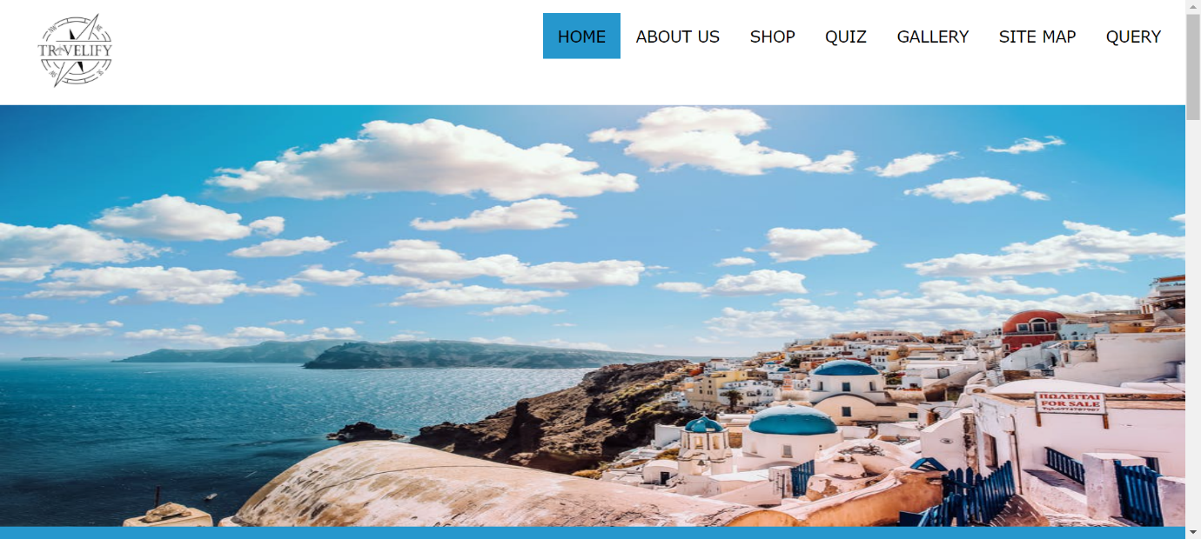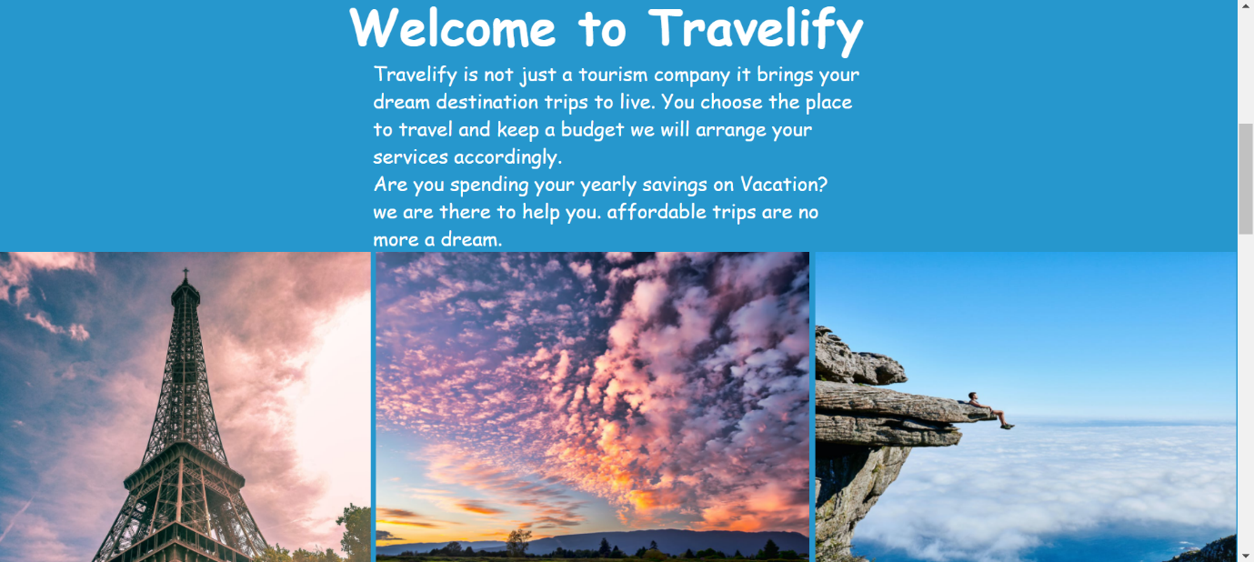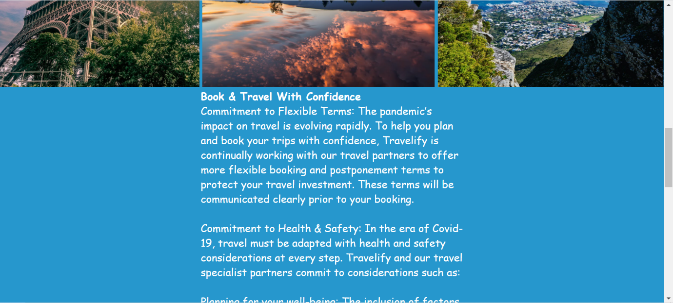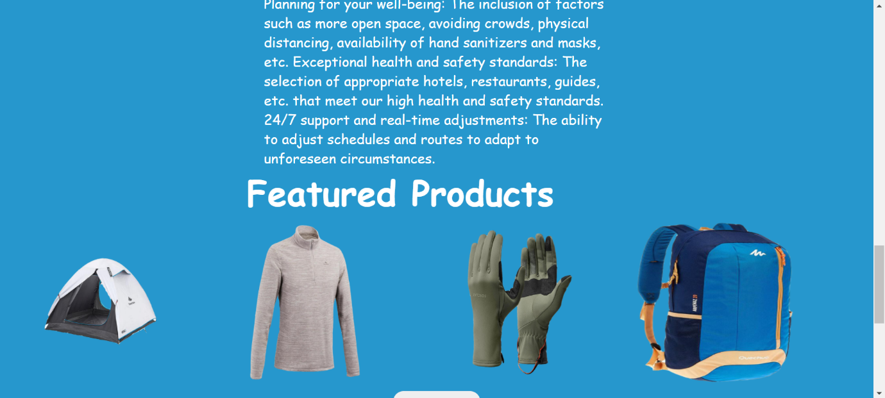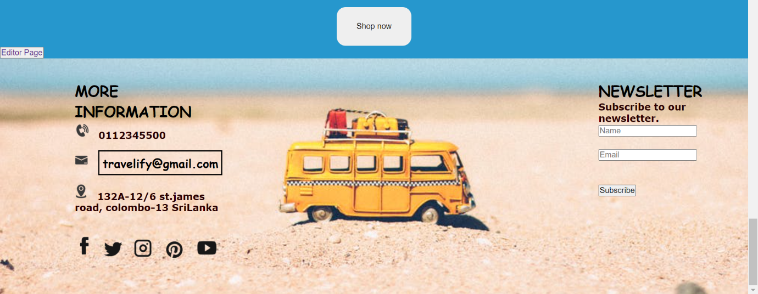

**Query.html**



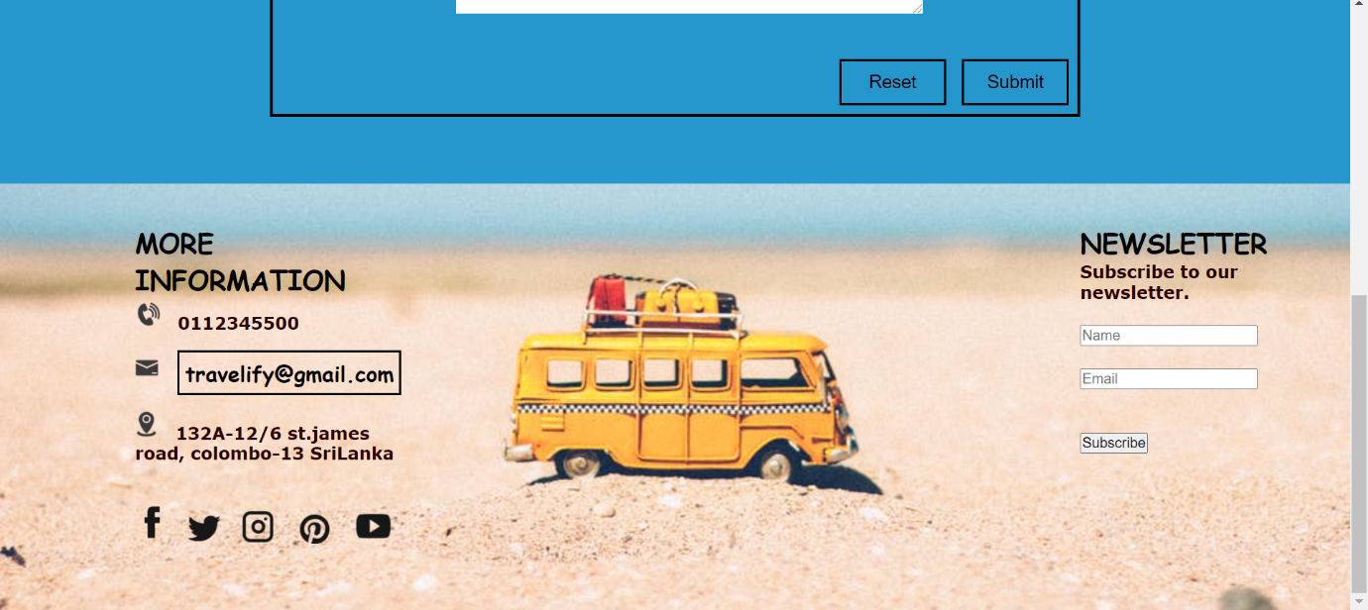

**Jeeona.html**

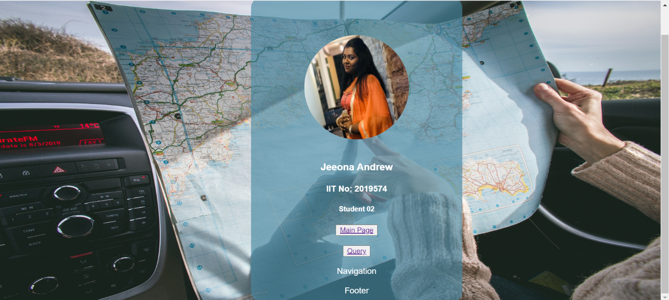

## Appendix C: Individual Statement

|  |  |  |  |
| --- | --- | --- | --- |
| Student Name: | Jeeona Andrew | Student Id: | W1810574 |
| State what tasks you carried out in the project. | | | |
| Main page  Navigation  Footer  Query | | | |
| State what you enjoyed and did not enjoy about teamwork. | | | |
| Enjoyed-  Learning new external CSS  Working with new member  Not Enjoyed-  Nothing | | | |
| State what you learnt about teamwork. | | | |
| Working in group  Respecting and listening other members opinion  Giving ideas | | | |
| State what skills you gained/learnt from undertaking the project. | | | |
| Improving my web developing skills. | | | |
| State any strengths about yourself that emerged whilst undertaking the project. | | | |
| Focused  Creativity  Teamwork | | | |
| State any weaknesses about yourself that emerged whilst undertaking the project. | | | |
| Self-criticism | | | |
| State how you would do things better if you were to undertake the project again. | | | |
| I will give more attention to the coursework and I will do better. | | | |
| Additional general or project specific comments: | | | |
| Had a good time in doing this coursework. | | | |
| Student Signature: | A.Jeeona | Date: | 25/03/2021 |